**Requirements Specification Document**

**Project M.A.R.K**

**(Medically Approved Record Keeper)**

**Alohomora Solutions**

**October 30th, 2018**

# Table of Contents

**Revision History 3**

1. **Introduction 4**
   1. Purpose 4
   2. Project Scope 4
   3. Glossary of Terms 4
   4. References 5
   5. Overview 5
2. **Overall Description 6**
   1. Product Perspective 6
   2. Product Features 6
   3. User Classes and Characteristics 6
   4. Operating Environment 7
   5. Design and Implementation Constraints 7
   6. Assumptions and dependencies 7
3. **System Features 7**
   1. Consolidation of Data 7
      1. Description and Priority 7
      2. Functional Requirements 7
      3. Use Case associated with the Feature or Functional Requirements 8
   2. Patient Search 8
      1. Description and Priority 8
      2. Functional Requirements 8
      3. Use Case associated with the Feature or Functional Requirements 9
   3. Record Search 9
      1. Description and Priority 9
      2. Functional Requirements 9
      3. Use Case associated with the Feature or Functional Requirements 9
   4. Append to Record Field 9
      1. Description and Priority 9
      2. Functional Requirements 9
      3. Use Case associated with the Feature or Functional Requirements 9
   5. Create New Patient Record 10
      1. Description and Priority 10
      2. Functional Requirements 10
      3. Use Case associated with the Feature or Functional Requirements 10
4. **External Interface Requirements 10**
   1. User Interfaces 10
   2. Software Interfaces 11
5. **Other Non-Functional Requirements 11**
   1. Performance Requirements 11
   2. Security Requirements 11
   3. Software Quality Attributes 12
6. **Use Cases 12**

Use Case 6.1 Authenticate User Account 12

Use Case 6.2 Search Patient 13

Use Case 6.3 Record Search 14

Use Case 6.4 Append to Patient Record Field 15

Use Case 6.5 Create New Patient Record 17

1. **Analysis Models 20**
   1. Use Case Model 20
   2. Entity Relationship Diagrams 21
   3. Data Flow Diagrams (DFDs) 21
      1. Context Diagram (DFD 0) 21
      2. DFD 1 22
      3. DFD 2 22
   4. Diagram Glossary 24

**Appendix A: Issues List 24**

**Appendix B: Client Correspondence 25**

# Revision History

|  |  |  |  |
| --- | --- | --- | --- |
| **Name** | **Date** | **Reason for Changes** | **Version** |
| Requirements Specification Document | Oct-30-2018 | Initial Draft | 0.9 |
|  |  |  |  |
|  |  |  |  |

# Introduction

## Purpose

This document will describe the software requirements for version 1.0 of Correcords, an electronic medical record (EMR) management system commissioned by Healthetica. Correcords will streamline the management of patient records within any medical institution that chooses to implement this system. The objective of this product is to remove existing bottlenecks in the record keeping process. The scope of this product covers the retrieval of patient data, entering it into a patient record, and syncing that data with a record stored in CareConnect.

## Project Scope

Correcords is an EMR management system designed to be implemented across connected medical institutions under Healthetica. The purpose of the product is to provide efficient workflows for medical personnel resulting in shortened wait times and more up-to-date knowledge of patient records. Achieving this will allow medical institutions to provide quicker and more accurate service to more patients. By ensuring consistent EMR data across multiple medical institutions, medical personnel can focus on providing care patients and not worry about whether the data is correct or updating data.

## Glossary of Terms

|  |  |
| --- | --- |
| **Term** | **Description** |
| CareConnect | The patient-centric eHealth Viewer used by the Province of British Columbia. It is considered an Electronic Health Record system as it is a cloud-based web service that provides authorized medical personnel with secure, view-only access to integrated clinical information from a multitude of health institutions and is accessible anywhere on the provincial network. |
| Correcords | Name of the product, EMR |
| Credentials | A medical personnel’s username and password |
| Data | All medical information within the patient record |
| Emergency information | Any data within the patient record that is pertinent to the patient’s life in critical situations such as allergies, blood type, date of birth, height, associated risks, and weight. |
| EMR | Electronic Medical Record |
| Local database | The database local to the medical institution, but external to the system |
| M.A.R.K. | “Medically Approved Record Keeper”; name of project |
| Medical institutions | Hospitals and clinics |
| Medical personnel | Doctors, nurses, and health managers |
| Patient identifier | Search criteria to find patient within local database |
| Patient data | All information inside a patient record |
| Patient record | A container for all patient data |
| Patient search bar | A search bar used to find patients |
| PHN | Personal Health Number |
| Product | Mentions of “the product” refer to Correcords |
| Record field | A specific category within a patient record, which contains specific data |
| Record search bar | A search bar used to find keys within the patient record |
| Search value | The values located in the field, eg. peanuts |
| System | The EMR (Correcords) |
| Timestamp | Date, time, and location of access |
| User | Doctors, nurses, and health managers |
| User account | An account of a user of the EMR |
| Workstation | A physical machine that the medical personnel have access to, eg. desktop |

## References

Bhattacharyya, S. (2018). Designing Hospital Information Systems | Information Technology. [online] Asian Healthcare Management System. Available at:

https://www.asianhhm.com/information-technology/hospital-information-systems [Accessed 30 Sep. 2018].

## Overview

The following sections of this document provide a general description, the characteristics of the users for this project and, the functional, non-functional, and data requirements of the system. General description of the project is discussed in section 2 of this document. Section 3 gives the project perspective and lists the features of the system. Section 3 also goes into deeper detail about the functional requirements and their use cases. Section 4 lists the external interface requirements. Section 5 details the non-functional requirements. Section 6 includes all the use cases. Section 7 includes all the models and diagrams relevant to the project.

# Overall Description

## Product Perspective

The system will be an EMR management system, which will replace the current medical standard. It will be a standalone system, however, it will connect with other larger systems such as CareConnect.

## Product Features

The major features of the system include:

* **Data Consolidation:** ​medical personnel will be able to see existing patient record from a different medical institution.
* **Patient Search:**​ medical personnel will be able to search for patient records.
* **Record Search:** ​medical personnel will be able to search patient record for specific patient data.
* **Append to Record Field**​: medical personnel will be able to append new data to patient record fields.
* **Create New Patient Record**​: selected medical personnel will be able to create new patient record if the patient does not exist in the system.

## User Classes and Characteristics

The following are the anticipated user classes of the system:

* Doctors
* Nurses
* Health managers

Doctors are responsible for diagnosing and assigning treatment to a patient and thus require the ability to create new patient records and to append to existing patient records. They must have full access to all patient records.

Nurses are responsible for monitoring and administering treatment to a patient and thus require the ability to append to existing patient records. They must have full access to all patient records.

Health managers are responsible for managing members of the medical institution staff. They deal with planning, directing, and coordinating the medical services of the department and thus require the ability to create new patient records and to append to existing patient records. They must have full access to all patient records.

These three classes will from here on be primarily referred to as medical personnel, however, in some contexts they will be referred to as users for the sake of coherence. Whenever used, these two terms refer to all three user classes unless specifically noted otherwise.

## Operating Environment

The operating environment is based on the environment on which the current system is installed. This requires compatibility with an operating system of Windows XP or higher. The software will also be compatible with external software components such as the existing authorization credentials and CareConnect. All software will be compatible with existing hardware platforms and servers.

## Design and Implementation Constraints

Design challenges include maintaining compatibility between CareConnect and the local database. The system will retrieve data from the local database and migrate any additions to CareConnect. This capability is described in section 3.1 Consolidation of Data. The implementation must strictly follow applicable privacy laws. The system will be constrained by the current hardware used within the adopting institution. Offline access will not be implemented as specified by the clients in Client Meeting #2 held on October 4th, 2018. Conflict resolution is not a concern with this implementation because any additions to a patient file are simply appended to the relevant field.

## Assumptions and dependencies

One assumption will be that the system integrates with the current database of patient records. In addition, two assumptions will be made about the existing hardware: first, that the hardware is accessible, and second that it is compatible with the system. By being accessible, the current hardware must be available for use. For compatibility, our system must be able to run on the current hardware with no issues.

There are two external factors on which the system depends. The system must sync with CareConnect and function with the current operating system running on machines within the medical institution.

# System Features

## Consolidation of Data

### Description and Priority

This feature is a high priority. The most recent and correct patient records should be available to medical personnel from any connected medical institution.

### Functional Requirements

**REQ-3.1.1**:​ The most recent patient records are retrieved from CareConnect when medical personnel search for patients.

1. This requirement was explicitly stated in the RFP 1.0 Problem Description and aims to “sync patient records between EMRs” using CareConnect and reduce “fragmentation of medical data.”
2. Verification of the requirement is TBD.

**REQ-3.1.2**:​ The updated patient records must be viewable from any medical institution connected to CareConnect.

1) This requirement was explicitly stated in the RFP 1.0 Problem Description and aims to increase “communication between EMRs.” 2) Verification of the requirement is TBD.

**REQ-3.1.3**:​ When a save button is selected, new data within the patient records must be updated automatically to CareConnect.

1) This requirement was explicitly stated in the RFP 1.0 Problem Description and aims to “sync patient records between EMRs” using CareConnect. 2) Verification of the requirement is TBD.

Error conditions:

* Failure to retrieve from CareConnect during system downtime results in an error notification.
* Failure to update to CareConnect during system downtime results in an error notification.

### Use Case associated with the Feature or Functional Requirements

The use cases associated with Consolidation of Data are use cases 6.2, 6.4, and 6.5. The uses cases and use case diagrams can be found in section 6.

## Patient Search

### Description and Priority

This feature is a high priority. Medical personnel must be able to retrieve an existing patient record from the local database and connected medical institutions.

### Functional Requirements

**REQ-3.2.1**:​ Any addition of data must be retrieved from CareConnect and must be updated with the local database.

1) This requirement was explicitly stated in the RFP 1.0 Problem Description and aims to “sync patient records between EMRs” using CareConnect and reduce “fragmentation of medical data.” 2) Verification of the requirement is TBD.

**REQ-3.2.2**:​ Medical personnel must be able to view list of existing patient records based on the results of the search value retrieved from the local database.

1. This requirement was not mentioned by the client, however, we deemed the function necessary for the system.
2. Verification of the requirement is TBD.

**REQ-3.2.3**:​​ Patient record must be time-stamped with the medical personnel’s name upon viewing the​ patient record.

1. This requirement was elicited in Client Meeting #2 held on October 4th, 2018.
2. Verification of the requirement is TBD.

Error conditions:

● Search value that yields no results displays a ‘No Results Found’ error message.

### Use Case associated with the Feature or Functional Requirements

The use cases associated with searching patient records is use case 6.2. The uses case and use case diagram can be found in section 6.

## Record Search

### Description and Priority

This feature is high priority as requested by the clients. Medical personnel should quickly be able to find specific data about a patient in their record.

### Functional Requirements

**REQ-3.3.1**:​ Value within a patient record must be searchable via search bar.

1. This was requested by the clients within the RD 1.1 review. This can be found in Appendix B under B.2.
2. Verification of the requirement is TBD.

### Use Case associated with the Feature or Functional Requirements

The use cases associated with searching record fields is use case 6.3. The uses case and use case diagram can be found in section 6.

## Append to Record Field

### Description and Priority

This feature is a high priority. Medical personnel have the ability to append new patient data into a patient record field. To ensure the integrity of patient records, medical personnel cannot remove data from a record.

### Functional Requirements

**REQ-3.4.1**:​ Modifying existing data is strictly forbidden because patient records must contain a complete history of past additions. Patient data cannot be removed.

1. Clients expressed the need for this within RD 1.1 feedback, which can be found in Appendix B under item B.3.
2. Verification of the requirement is TBD.

**REQ-3.4.2**:​ Information about when the append was made, who made it, and at which workstation it was made will be visible.

1. The entire history of the record should be transparent, which was mentioned by the clients in several meetings. Email correspondence can be found in Appendix B under item B.4.
2. Verification of the requirement is TBD.

### Use Case associated with the Feature or Functional Requirements

The use cases associated with appending to record field is use case 6.4. The uses case and use case diagram can be found in section 6.

## Create New Patient Record

### Description and Priority

The system requires this feature, but it was not explicitly stated by the clients, therefore, it has a medium priority. The ability to create a new patient record must be used when a patient record does not currently exist in the system. Permission to create a new patient record is only given to doctors and health managers. When this option is selected, an empty patient record form is displayed with further options to save or cancel the creation of the new record.

### Functional Requirements

**REQ-3.5.1**:​ Entering previously non-existent patient records into the system. This requires a “create new record” button, which is only available to doctors and health managers. It will still appear for nurses but will be grey and unselectable.

1. This requirement was not mentioned by the client, however, we deemed the function necessary for the system.
2. Verification of the requirement is TBD.

**REQ-3.5.2**:​ Minimum data required to create a new record. A new record cannot be saved unless the specifically marked fields have been filled. For example: PHN, name, date of birth, and address.

1. This requirement was not mentioned by the client, however, we deemed the function necessary for the system.
2. Verification of the requirement is TBD.

Error conditions or invalid inputs:

* Patient record uniqueness is ensured through the PHN of every patient in the database. When the save button is pressed the system will check all existing records to ensure this patient record does not already exist.
* Invalid inputs within patient record fields will be detected when the save button is pressed. These will include invalid characters and insecure phrases leading to code injection.

### Use Case associated with the Feature or Functional Requirements

The use cases associated with creating new patient records is use case 6.5. The uses case and use case diagram can be found in section 6.

# External Interface Requirements

## User Interfaces

The user interface requirements are dictated by Healthetica. The user interface environment will be constructed to be accessible, intuitive, and organized. It also acts as a replacement for CareConnect’s interface. The interface will allow medical personnel to retrieve data from CareConnect and, with the correct level of authorization, view patient records. The medical personnel without the proper level of authorization will not be able to access data, but will still be notified if it exists.

In order to serve the user base, usability is a very high priority of the user interface. To achieve a high level of usability, we have redesigned the page layouts at every level of the system. The main view, a patient record, is organized in an easy-to-read, tile layout where basic and emergency information is always displayed at the top with a tile interface below. Each tile represents a different patient field such as allergies, medications, surgeries. Search bars are very important to the clients, so we have made them plainly visible at the top of the patient record.

## Software Interfaces

The data entered into the system must be synced with CareConnect. Therefore, an interface between these two services must exist. Data is entered into the system by an authorized medical personnel to update an existing patient record or enter a new patient record. The data from the system must then be synced to CareConnect. This is a vital component of the software as it ensures that connected medical institutions have identical patient records. The system will operate on the operating system currently installed on the machines in the adopting medical institutions.

# Other Non-Functional Requirements

## Performance Requirements

Two major performance requirements are reliability and real-time display. Reliability is defined as the time for which the system is available to medical personnel. Reliability must exceed rates of 99.9% in non-clinical environments and 100% in clinical environments (Bhattacharyya, 2018). Real-time display is defined as the ability for multiple medical personnel to see new data additions as they are appended. Additions made in a patient record must be visible to other medical personnel within 1 second.

## Security Requirements

Authorized medical personnel must comply with the security requirements. The following security requirements are absolutely necessary:

* Only authorized medical personnel can access the system.
* When a medical personnel views a patient record, a timestamp is entered into the local database.
* When a medical personnel creates a new record or appends to a patient record, a timestamp is entered into the local database.

Authorization will be used to control access to patient records based on the medical personnel’s privileges. The available authorization levels are categorized into the following three tiers:

* Tier 1 - Health Manager
* Tier 2 - Doctor
* Tier 3 - Nurse

## Software Quality Attributes

In descending order of priority, the required software quality attributes are: correctness, adaptability, and usability.

Correctness is defined as the accuracy of patient data which includes, but is not limited to: blood type, current medications, and allergy data. Correctness of data is necessary in order to ensure proper medical treatment. Pulling of patient data (from both local database and CareConnect) must be correct 100% of the time.

Interoperability is defined as the ability to connect to external software components such as

CareConnect and the existing authorization system. The system must be able to communicate fully with CareConnect 100% of the time.

Usability is defined as the user’s ability to quickly and easily locate the necessary patient data. This requires data to displayed in a well-organized manner.

# Use Cases

## Use Case 6.1 Authenticate User Account

**Description:** Authenticating a user account involves medical personnel logging into a workstation with​ the system installed with their unique credentials. If the user is authorized, they gain access to the system, otherwise, they are not given access.

**Specifications**:​

**Actors**:​ Medical personnel (MP)

**Pre-conditions**:​ MP has access to workstation with the system installed **Steps**:​

1. MP enters credentials
2. MP submits the login request
3. Credentials accepted

**Success Condition**:​ Gain access to the system

**Alternate Path(s)**:​

3) Credentials not accepted

**Alternate Post Condition:** Error message “Credentials incorrect” and access to the​ system not granted **Sequence diagram:**

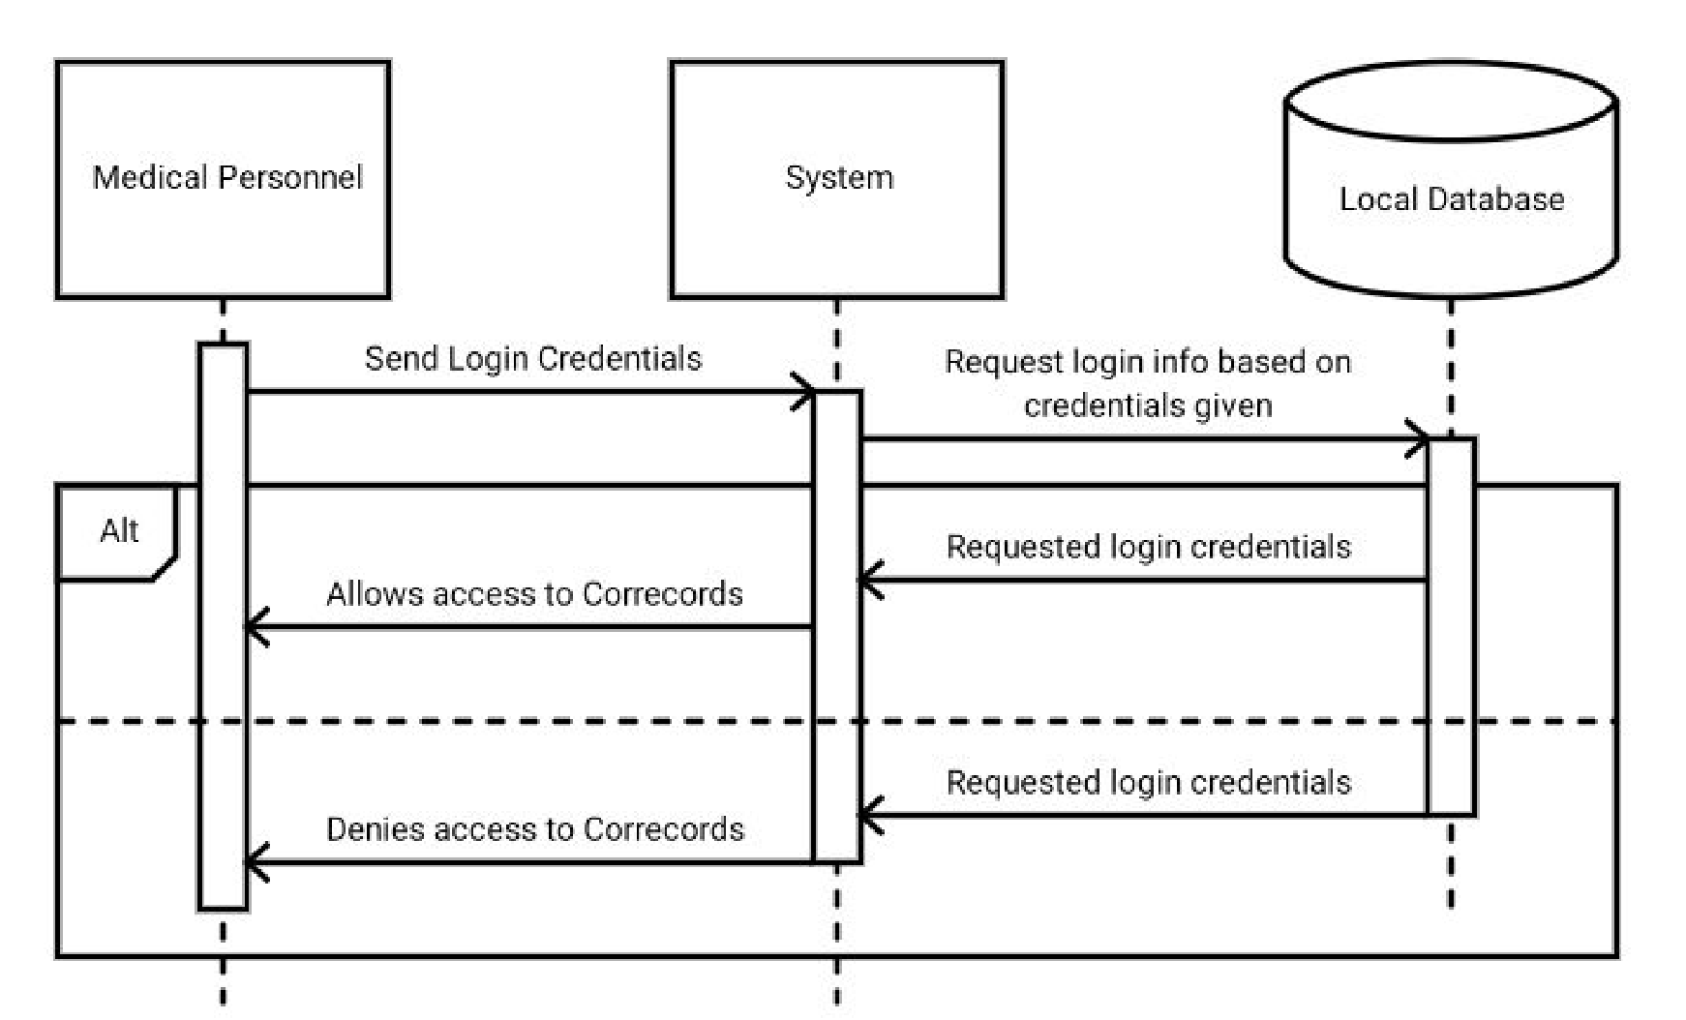

## Use Case 6.2 Search Patient

**Description:** Displaying a patient record requires that the medical personnel have access to the system​ (Use case 6.1). The medical personnel then enters the relevant patient identifier into the patient search bar. If a match is found, the results are displayed to the medical personnel, otherwise, no matching records exist in the local database. After search request is sent, local database is consolidated with CareConnect to ensure local database has the most recent patient record.

When a patient record is displayed, the timestamp of access, name of the medical personnel, and the location it was accessed are recorded to the local database and saved on the patient record.

**Specification**:​

**Actors**:​ Medical personnel (MP)

**Pre-conditions**:​ Authenticate User Account (Use case 6.1)

**Steps**:​

1. MP selects patient search bar
2. MP enters patient identifier
3. MP submits patient search request
4. Requested patient record found in database

**Success Condition**:​ Requested patient record displayed

**Alternate Path(s)**:​

4) Patient record does not exist in database

**Alternate Post Condition:** Error message “No results found”​ **Sequence diagram:**

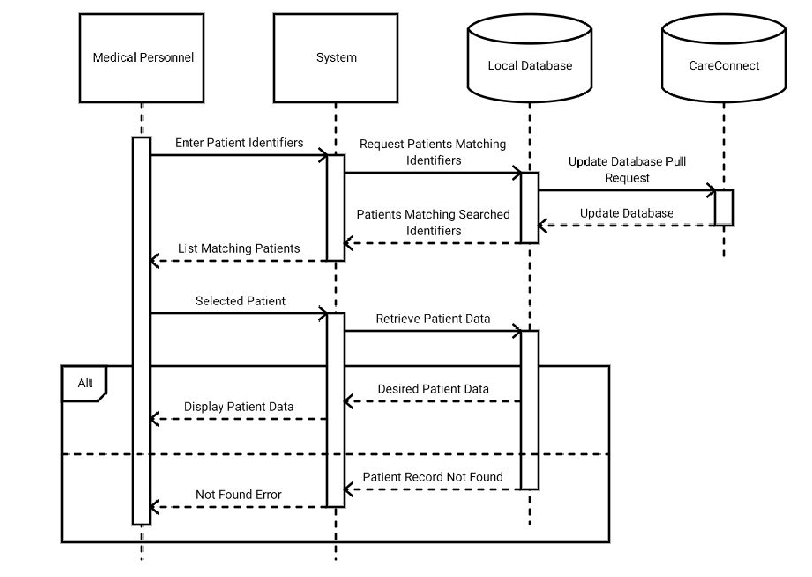

## Use Case 6.3 Record Search

**Description:** Searching record fields requires that the medical personnel have access to the system (Use​ case 6.1). The medical personnel then enter the requested value into the search bar. If the value exists, value is displayed, otherwise, the value does not exist within the record.

**Specification**:​

**Actors**:​ Medical Personnel (MP)

**Pre-conditions**:​ Patient Search (Use case 6.2)

**Steps**:​

1) MP selects record search bar 2) MP enters search value

2.1) Drop-down autofill window appears below the search bar and is accordingly

populated

1. MP submits search value request
2. Requested value found

**Success Condition**​: Requested value displayed **Alternate Path(s)**​:

4) Requested value not found

**Alternate Post Condition:**​ Message “No results found” **Sequence diagram:**

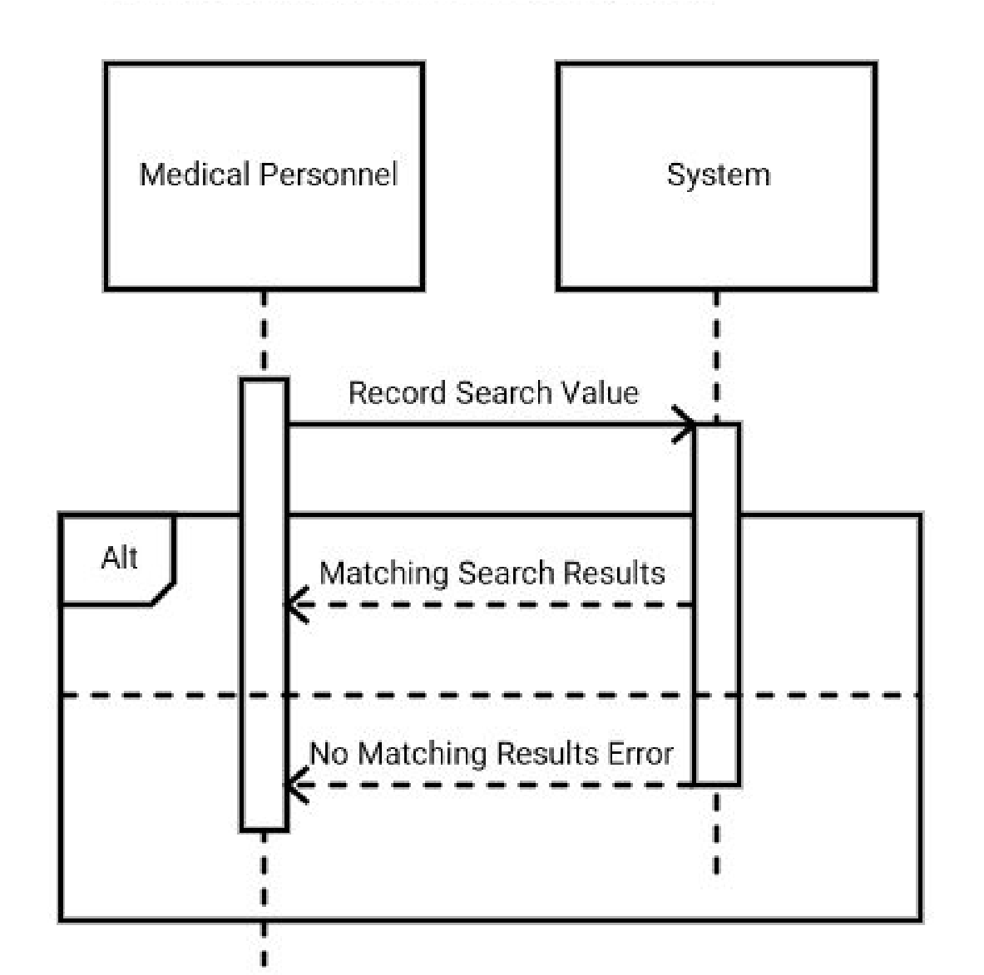

## Use Case 6.4 Append to Patient Record Field

**Description:** ​Appending to a patient record requires that the medical personnel have access to the EMR (Use case 6.1). The medical personnel then selects the field to which they would like to add new patient data. New patient data is then entered. The medical personnel submits the save request followed by a confirmation notification. When a patient record is updated, the timestamp of the update, name of the medical personnel, and the location it was updated are recorded to the local database and saved on the patient record.

Medical personnel can choose to cancel the changes instead of saving. This will prompt for confirmation of cancellation, followed by a notification indicating that the record has not been updated.

If value is not updated to the patient record and/or local database due to technological or connective issues, error notification will be displayed, “An error occurred. Your change could not be saved.” **Specification**​:

**Actors**​: Medical Personnel (MP)

**Pre-conditions**​: Patient Search (Use case 6.2)

**Steps**:​

1. MP selects or searches for a record field
2. MP creates a new append request
3. MP enters new patient data
4. MP submits the new record append request
   1. MP confirms the append request
   2. Display confirmation notification (“Record Updated”)

**Success Condition**:​ Local database is updated and consolidated with CareConnect.

**Alternate Path(s)**:​

4.2) Display error notification **Alternate Post Condition(s):**

* + - Local databases is not updated.
    - Error message “An error occurred. Your changes could not be saved”

1. MP cancels the new record append request
   1. MP cancels the append request
   2. Display cancel notification (“Record Not Updated”) **Alternate Post Condition**:​ Local database is not updated.

**Sequence diagram:**

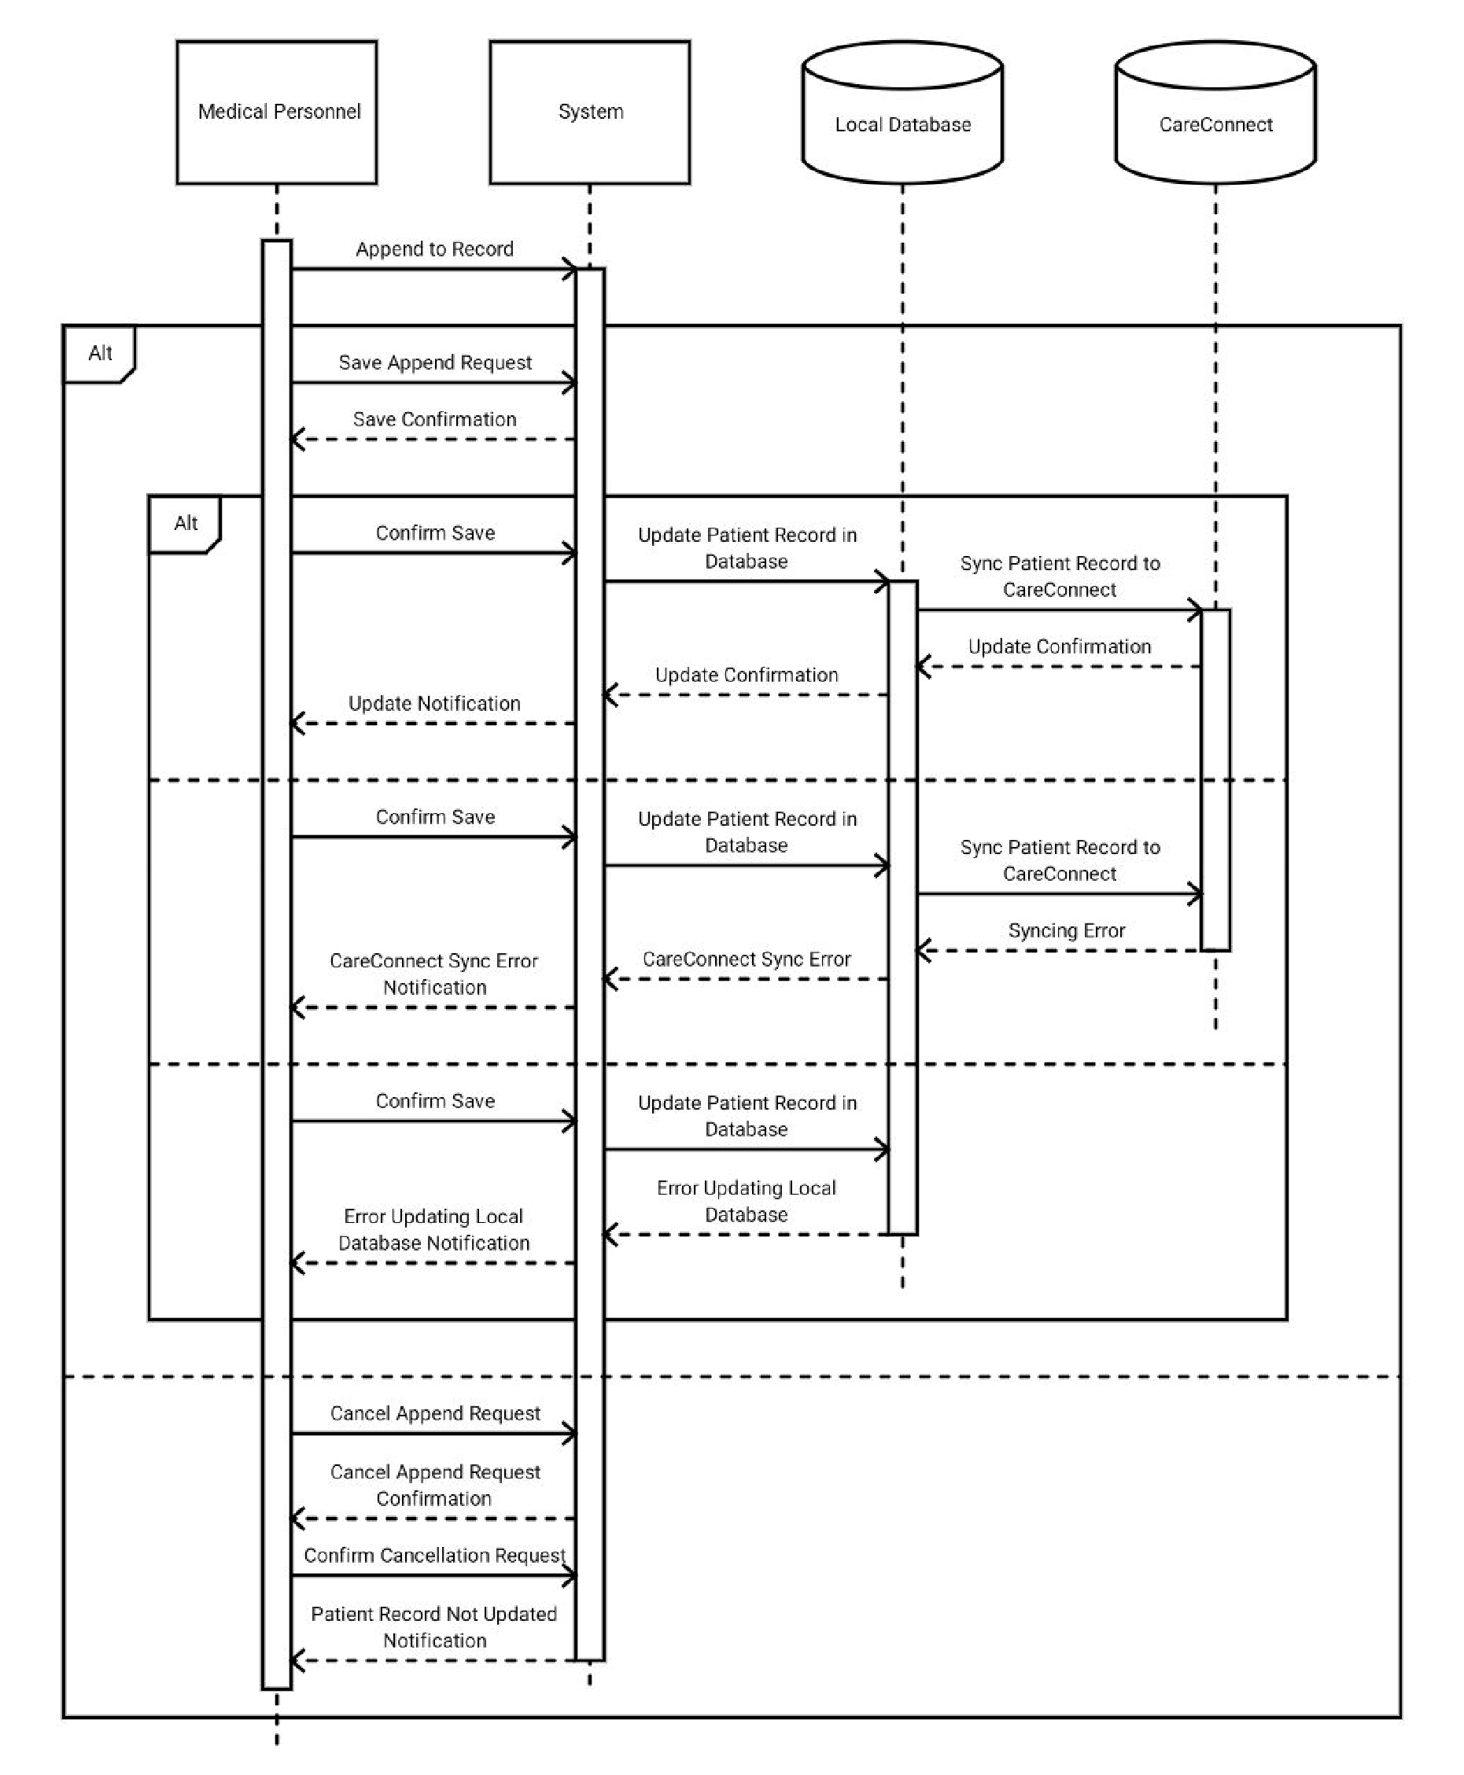

## Use Case 6.5 Create New Patient Record

**Description:** Creating a new patient record requires that the medical personnel: have access to the​ system (Use case 6.1), are a health manager or a doctor, and that the patient record does not already exist in the database. Health managers or doctors can create a new record by entering the initial patient data. The health manager or doctor can then choose to save the record or cancel the creation process. When a patient record is created, the time of creation, name of the medical personnel, and the location it was created are recorded to the local database and CareConnect and saved on the patient record.

**Specifications**:​

**Actors:** Health Managers and Doctors (HM & D)​

**Pre-conditions:** Authenticate User Account (Use case 6.1), patient record does not exist in local​ database

**Steps:**

1. HM & D creates a new record request
2. HM & D enter new patient data into empty record
3. HM & D submits new record request
   1. HM & D confirms the new record request
   2. Display confirmation notification (“Record Created”) **Success Condition:**

* New patient record created
* Local database updated
* CareConnect updated

**Alternate Path(s):**

3) HM & D cancels the new record request

* 1. HM & D confirms the cancellation
  2. Display cancel notification (“Record Not Created”) **Alternate Post Condition:**
* Patient record not created
* Local database not updated
* CareConnect not updated **Sequence diagram:**

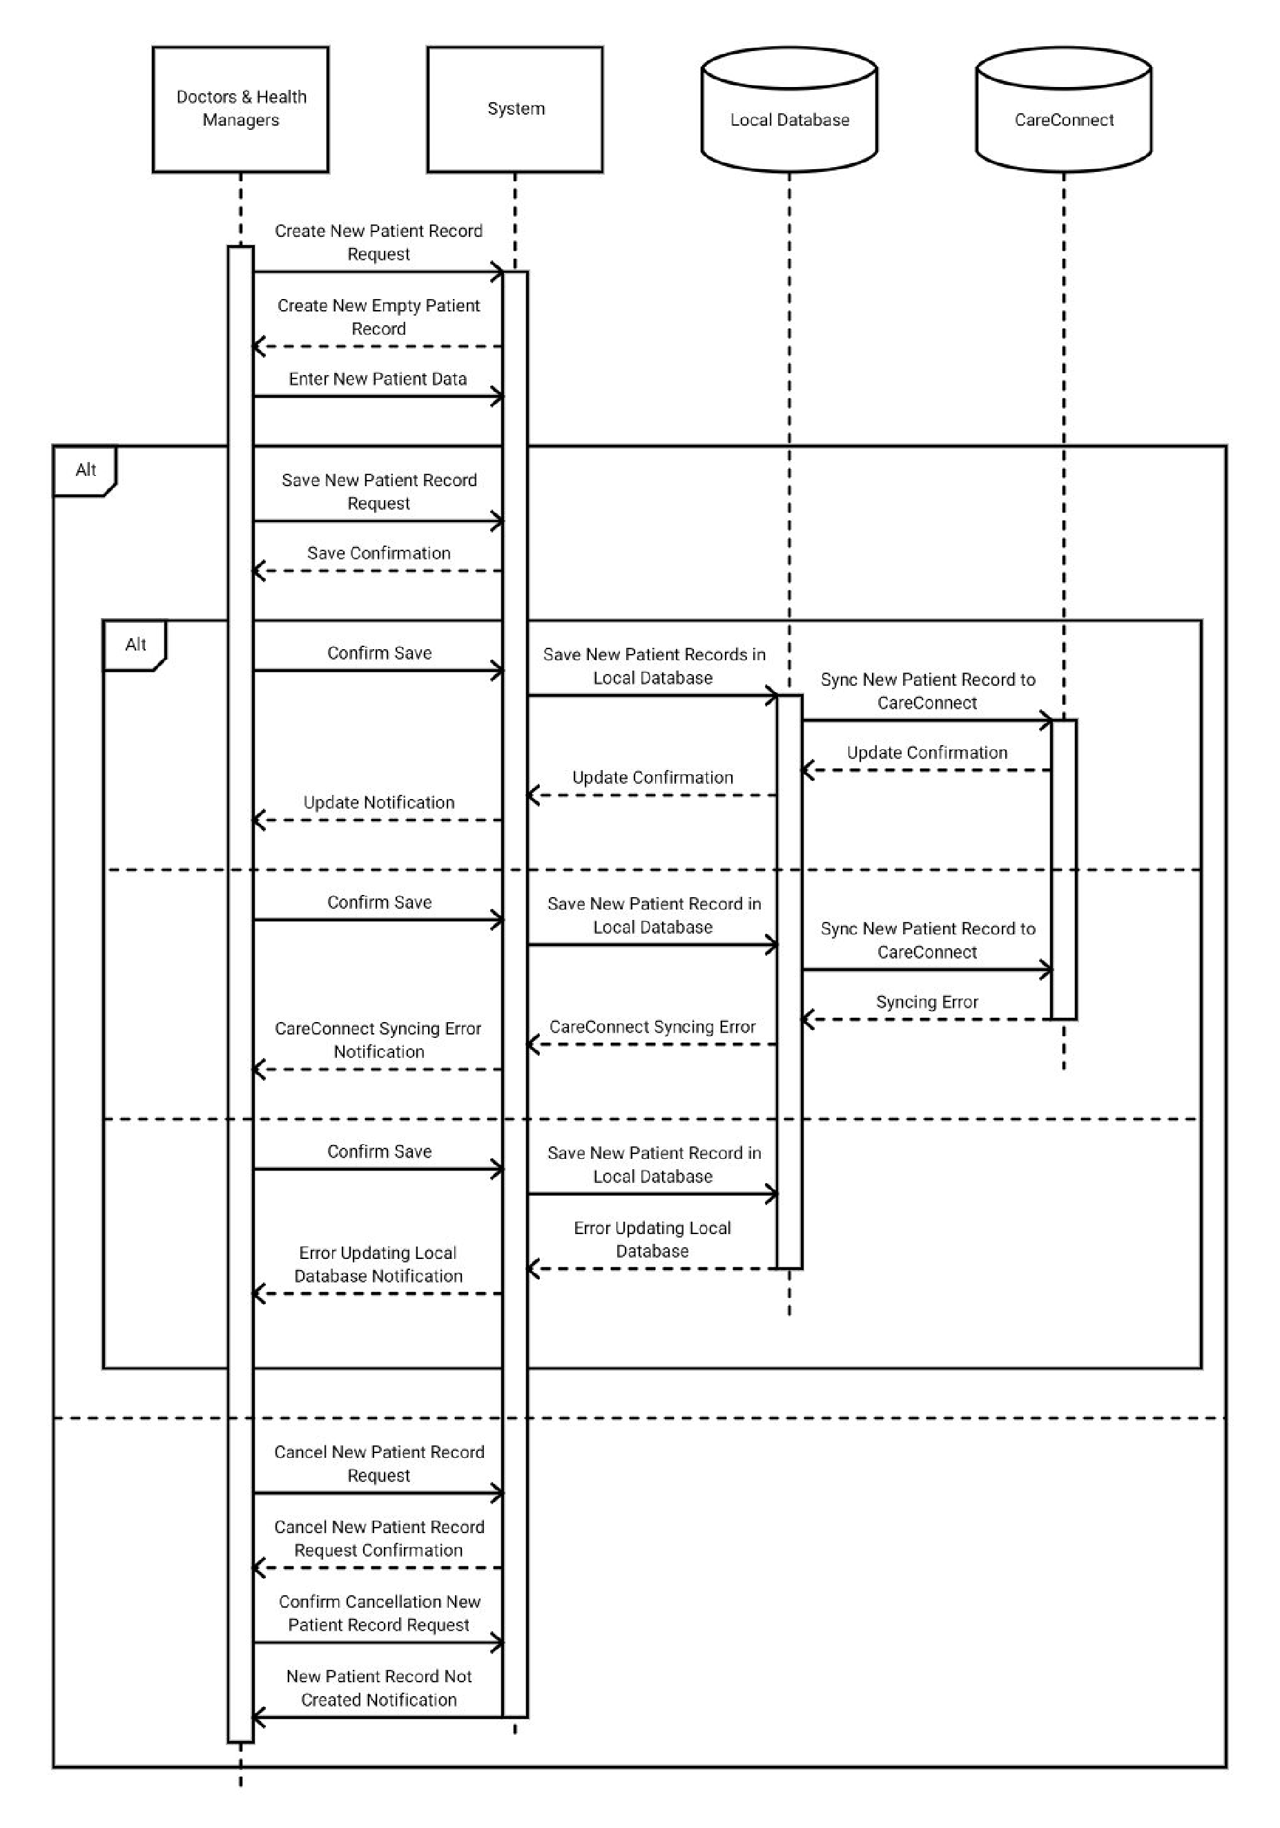

# Analysis Models

## Use Case Model

**Description**​: This diagram shows the use cases of the system and its corresponding actors, actions, and their associations. These use cases are also specified in Section 6.

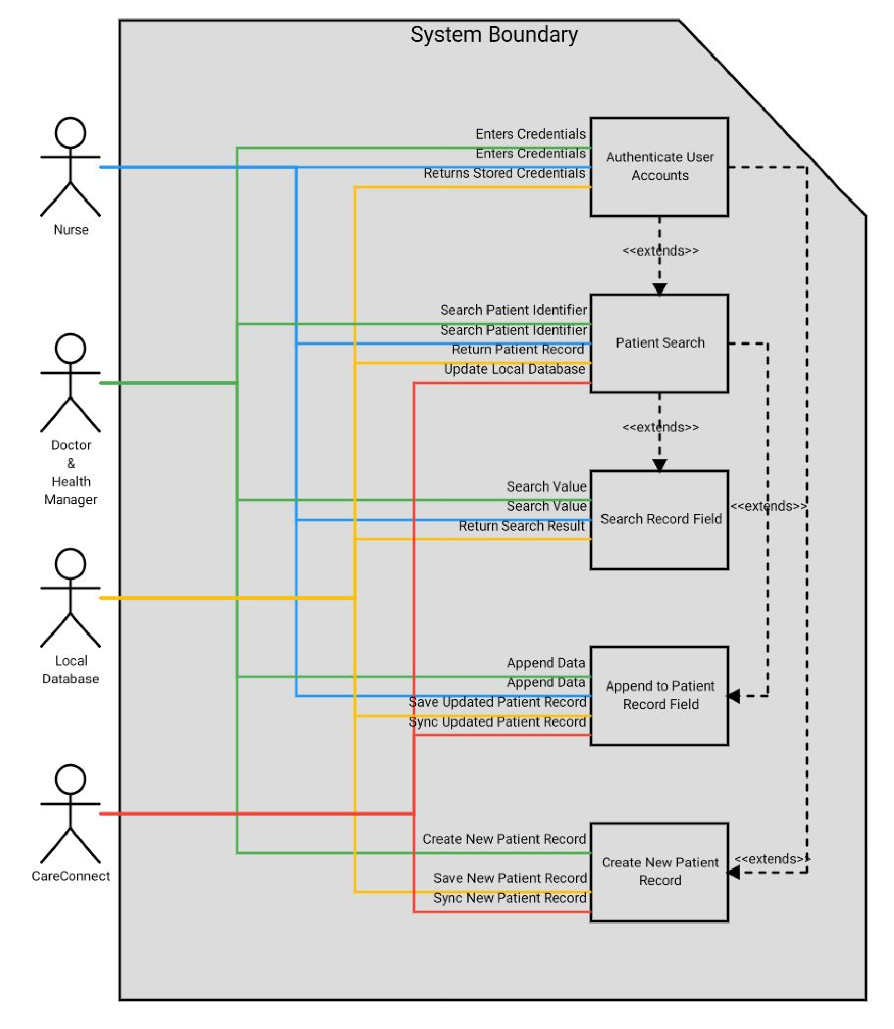

## Entity Relationship Diagrams

**Description**:​ This diagram describes the database entities, examples of their attributes, and their relationships with each other. Some of the assumptions of the diagram are:

1. Patient entity must have a PHN
2. User must have valid credentials

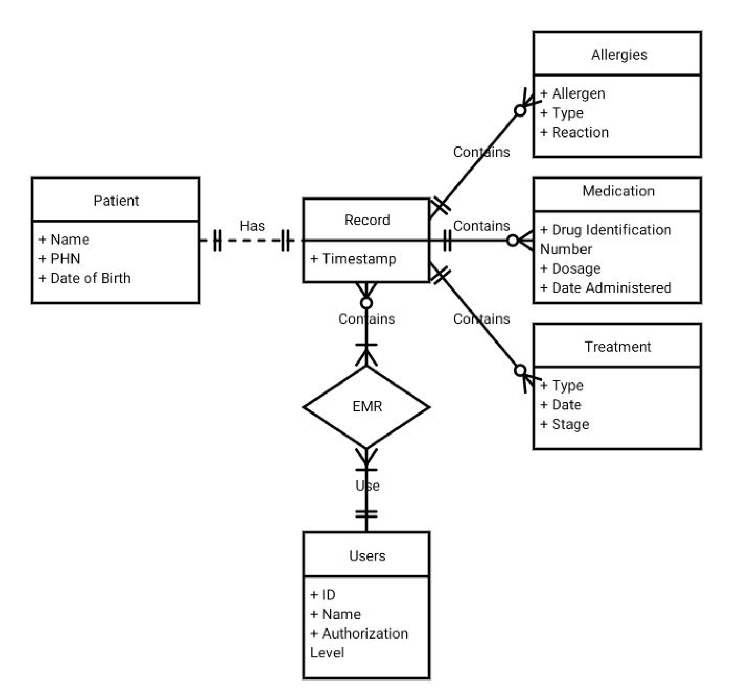

## Data Flow Diagrams (DFDs)

### Context Diagram (DFD 0)

**Description**:​ The context diagram describes what data goes in and out of the system (at the highest possible level), how external entities interact with the system, and the data that is exchanged during each interaction.

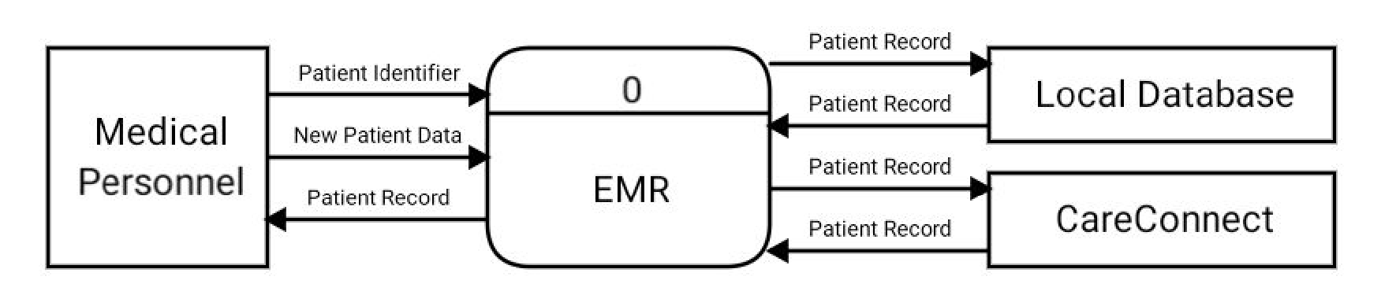

### DFD 1

**Description**:​ The data flow diagram at level 1 describes the main processes of the system and how they receive input data and produce output data. It also shows what data is exchange amongst processes and entities internal and external to the system.

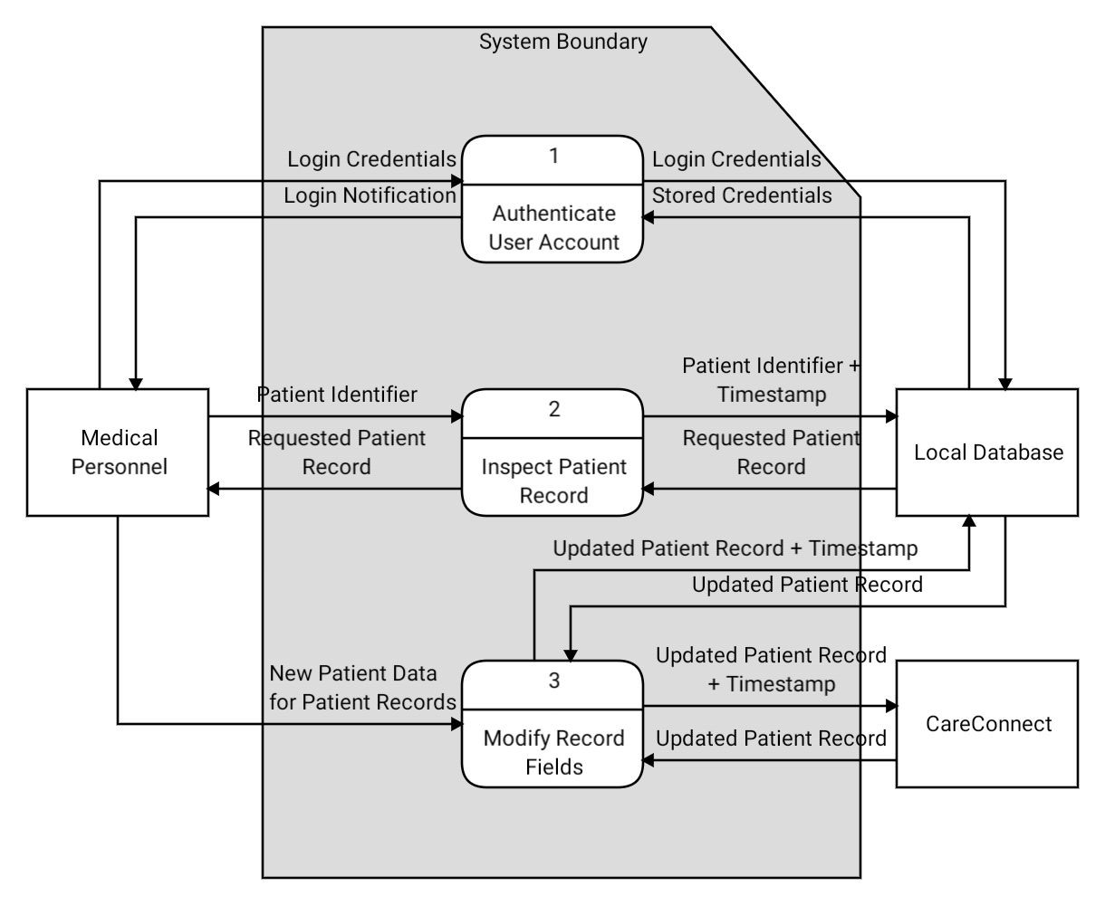

### DFD 2

**Description**:​ The data flow diagram at level 2 expands on the processes outlined in DFD 1 (Section 7.3.2) in more depth. These processes are representative of the use cases outlined in Section 6.

Note that “Authenticate User account” process is the login process.

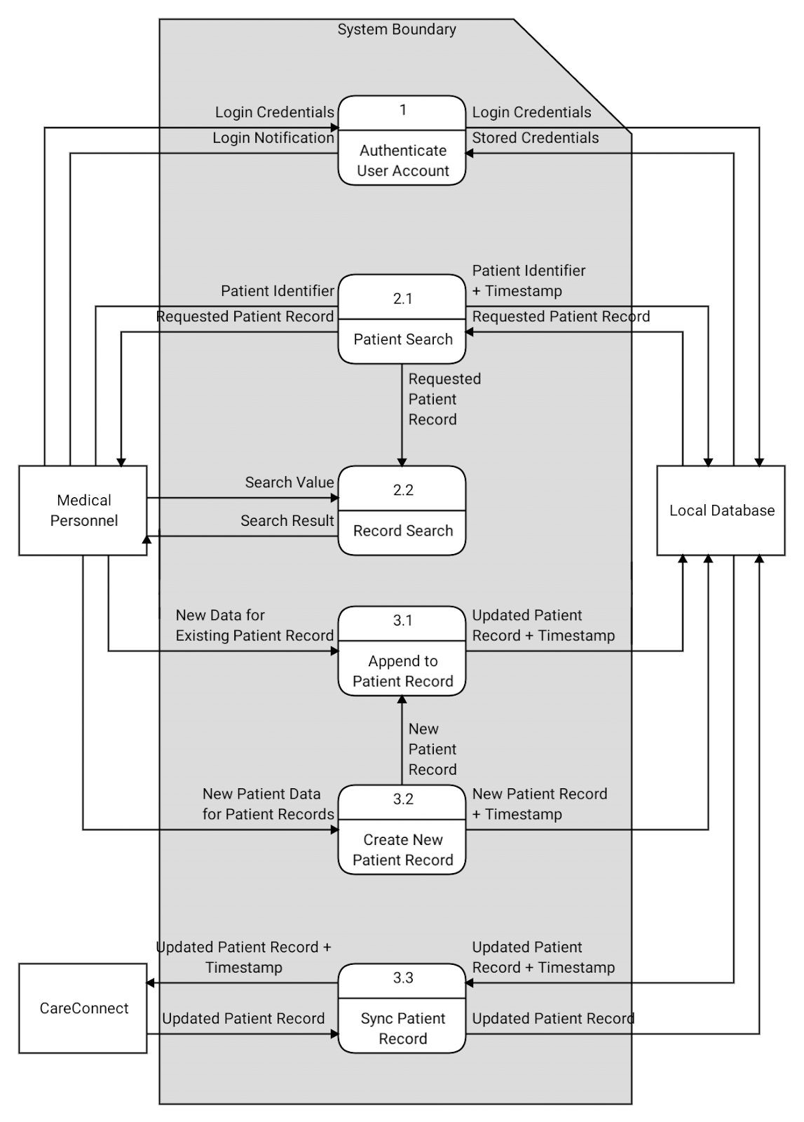

## Diagram Glossary

|  |  |
| --- | --- |
| **Term** | **Definition** |
| Alt | Alternate path |
| Notification | A message prompt to notify the user |

# Appendix A: Issues List

|  |  |  |
| --- | --- | --- |
| **Issue** | **Description** | **Date** |
| Backward Traceability | How all functional requirements will be verified is TBD. | Oct-30-2018 |

# Appendix B: Client Correspondence

B.1: Email with Ethan Kwan from Group 3 - October 6th 2018

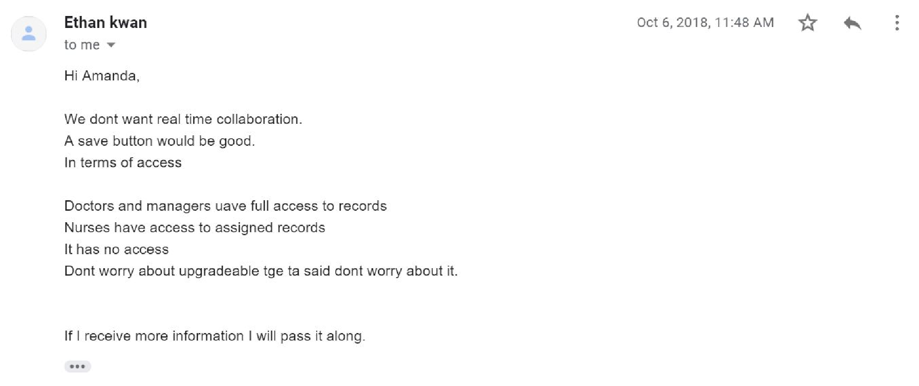

B.2: Comment from Group 3 on the RD1.1 indicating the need for a search bar.

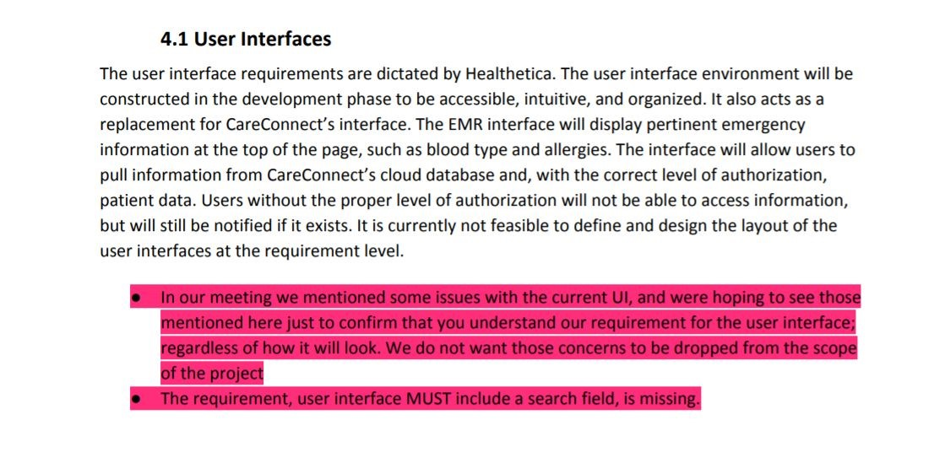

B.3: Comment from Group 3 on the RD1.1 indicating zero removal of data.

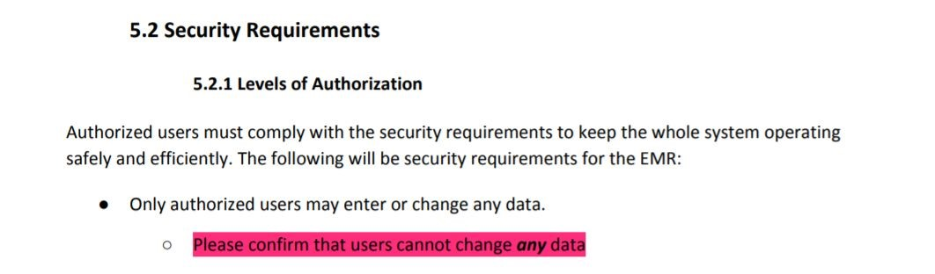

B.4: Comment from Group 3 on the RD1.1 indicating the need for a paper trail.

